**Advance Excel Assignment 2**

1. What does the dollar($) sign do?

Ans : It refers three ways.

1. It indicates a type of currency

2. In absolute references it is used before row number and column number that means the cells wont change in formula .

3. In mixed reference it is used either in front of row number or column number that means if it used before row that row wont be changed. If it used before column name that column name wont be changed.

1. How to Change the Reference from Relative to Absolute (or Mixed)?

In relative or mixed references we use dollar symbol before row and column number. If we remove dollar symbol then it will be changed to Absolute reference.

To change the type of cell reference:

(i). Select the cell that contains the formula.

(ii). In the formula bar Button image, select the reference that you want to change.

(iii). Press F4 to switch between the reference types.

The table below summarizes how a reference type updates if a formula containing the reference is copied two cells down and two cells to the right.

| **For a formula being copied:** | **If the reference is:** | **It changes to:** |
| --- | --- | --- |
| Formula being copied from A1, to two cells down and to the right | $A$1 (absolute column and absolute row) | $A$1 (the reference is absolute) |
|  | A$1 (relative column and absolute row) | C$1 (the reference is mixed) |
|  | $A1 (absolute column and relative row) | $A3 (the reference is mixed) |
|  | A1 (relative column and relative row) | C3 (the reference is relative) |

1. Explain the order of operations in excel?

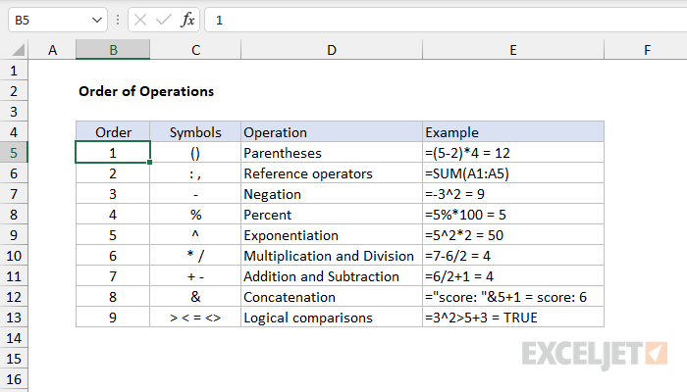

In general, Excel's order of operation follows the acronym PEMDAS (Parentheses, Exponents, Multiplication, Division, Addition, Subtraction) but with some customization to handle the formula syntax in a spreadsheet.

First, any expressions in parentheses are evaluated. Parentheses essentially override the normal order of operations to ensure certain operations are performed first.

Next, Excel will resolve references. This involves replacing cell references like A1 with the value from the cell, as well as evaluating range references like A1:A5, which become arrays of values. Other range operations like union (comma) and intersection (space) also happen at this time.

Next, Excel will perform exponentiation, negation, and percent conversions (in that order), followed by multiplication and division, addition and subtraction, and concatenation. Finally, Excel will evaluate logical operators, if present.

In summary, Excel solves formulas in the following order:

Parentheses

Reference operators

Exponents

Negation

Percent

Multiplication and Division

Addition and Subtraction

Concatenation

Logical operators

*Note: If a formula contains multiple operators with the same priority (e.g. multiplication and division, or addition and subtraction), Excel will evaluate the operators from left to right.*

4. What, according to you, are the top 5 functions in excel and write a basic syntax for any of two?

There are many formulas in excel that are frequently used. According to me the top 5 are :

1. Sum *(=sum(range))*
2. Count *(=count(range))*
3. Average *(=average(range))*
4. Min *(=min(range))*
5. Max *(=max(range))*

5. When would you use the subtotal function?

Returns a subtotal in a list or database. It is generally easier to create a list with subtotals by using the Subtotal command in the Outline group on the Data tab in the Excel desktop application. Once the subtotal list is created, you can modify it by editing the SUBTOTAL function.

Syntax: SUBTOTAL(function\_num,ref1,[ref2],...)

The SUBTOTAL function syntax has the following arguments:

* **Function\_num**     Required. The number 1-11 or 101-111 that specifies the function to use for the subtotal. 1-11 includes manually hidden rows, while 101-111 excludes them; filtered-out cells are always excluded.

| **Function\_num** **(includes hidden rows)** | **Function\_num** **(ignores hidden rows)** | **Function** |
| --- | --- | --- |
| 1 | 101 | AVERAGE |
| 2 | 102 | COUNT |
| 3 | 103 | COUNTA |
| 4 | 104 | MAX |
| 5 | 105 | MIN |
| 6 | 106 | PRODUCT |
| 7 | 107 | STDEV |
| 8 | 108 | STDEVP |
| 9 | 109 | SUM |
| 10 | 110 | VAR |
| 11 | 111 | VARP |

* **Ref1**     Required. The first named range or reference for which you want the subtotal.
* **Ref2,...**     Optional. Named ranges or references 2 to 254 for which you want the subtotal.

REMARKS:

* If there are other subtotals within ref1, ref2,… (or nested subtotals), these nested subtotals are ignored to avoid double counting.
* For the function\_num constants from 1 to 11, the SUBTOTAL function includes the values of rows hidden by the Hide Rows command under the Hide & Unhide submenu of the Format command in the Cells group on the Home tab in the Excel desktop application. Use these constants when you want to subtotal hidden and nonhidden numbers in a list. For the function\_Num constants from 101 to 111, the SUBTOTAL function ignores values of rows hidden by the Hide Rows command. Use these constants when you want to subtotal only nonhidden numbers in a list.
* The SUBTOTAL function ignores any rows that are not included in the result of a filter, no matter which function\_num value you use.
* The SUBTOTAL function is designed for columns of data, or vertical ranges. It is not designed for rows of data, or horizontal ranges. For example, when you subtotal a horizontal range using a function\_num of 101 or greater, such as SUBTOTAL(109,B2:G2), hiding a column does not affect the subtotal. But, hiding a row in a subtotal of a vertical range does affect the subtotal.
* If any of the references are 3-D references, SUBTOTAL returns the #VALUE! error value.

Example: Copy the example data in the following table, and paste it in cell A1 of a new Excel worksheet. For formulas to show results, select them, press F2, and then press Enter. If you need to, you can adjust the column widths to see all the data.

| **Data** |  |  |
| --- | --- | --- |
| 120 |  |  |
| 10 |  |  |
| 150 |  |  |
| 23 |  |  |
| **Formula** | **Description** | **Result** |
| =SUBTOTAL(9,A2:A5) | The sum of the subtotal of the cells A2:A5, using 9 as the first argument. | 303 |
| =SUBTOTAL(1,A2:A5) | The average of the subtotal of the cells A2:A5, using 1 as the first argument. | 75.75 |
| ***Notes*** |  |  |
| *The SUBTOTAL function always requires a numeric argument (1 through 11, 101 through 111) as its first argument. This numeric argument is applied to the subtotal of the values (cell ranges, named ranges) that are specified as the arguments that follow.* | | |

6. What is the syntax of the vlookup function? Explain the terms in it?

Use VLOOKUP when you need to find things in a table or a range by row. For example, look up a price of an automotive part by the part number, or find an employee name based on their employee ID.

In its simplest form, the VLOOKUP function says:

=VLOOKUP(What you want to look up, where you want to look for it, the column number in the range containing the value to return, return an Approximate or Exact match – indicated as 1/TRUE, or 0/FALSE).

There are four pieces of information that you will need in order to build the VLOOKUP syntax:

1.The value you want to look up, also called the lookup value.

2.The range where the lookup value is located. Remember that the lookup value should always be in the first column in the range for VLOOKUP to work correctly. For example, if your lookup value is in cell C2 then your range should start with C.

3.The column number in the range that contains the return value. For example, if you specify B2:D11 as the range, you should count B as the first column, C as the second, and so on.

4.Optionally, you can specify TRUE if you want an approximate match or FALSE if you want an exact match of the return value. If you don't specify anything, the default value will always be TRUE or approximate match.

Now put all of the above together as follows:

*=VLOOKUP(lookup value, range containing the lookup value, the column number in the range containing the return value, Approximate match (TRUE) or Exact match (FALSE)).*

=VLOOKUP (B3,B2:E7,2,FALSE)

VLOOKUP looks for Fontana in the first column (column B) in the table_array B2:E7, and returns Olivier from the second column (column C) of the table_array.  False returns an exact match. =VLOOKUP (102,A2:C7,2,FALSE)

VLOOKUP looks for an exact match (FALSE) of the last name for 102 (lookup_value) in the second column (column B) in the A2:C7 range, and returns Fontana.